Visual Studio Code Instructions

I will send you the html file for the smaller category descriptions. If you right-click and select Open With: Microsoft Visual Code it will be colour-coded.

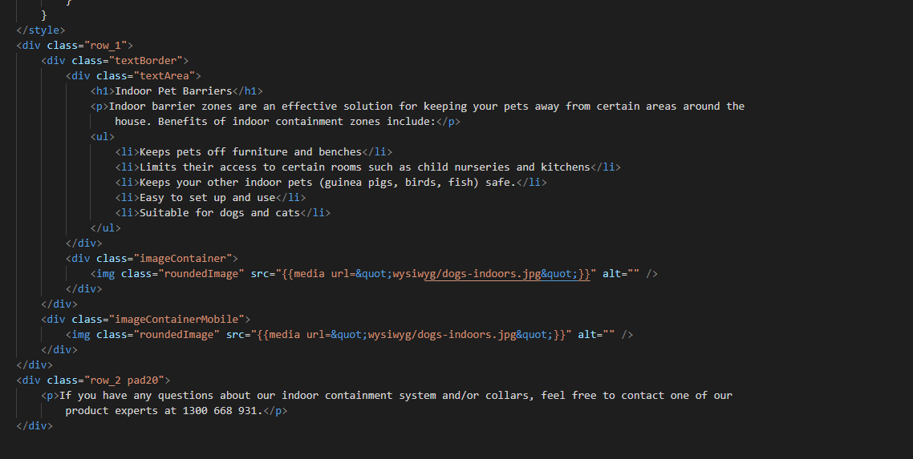

Just edit the white code to change the text. You can add or remove the bullet points by using the <li> </li> attribute. If you can, try to make the content the same amount of words, or I may need to change the spacing and size (not a big deal).

To change the images, you will see an attribute <img> with the URL source. In the Magento category page (backend) just scroll to the bottom of all the text and create a new line. Select insert image then upload or select as you need, and then add selected. The image size on desktop is 505 x 350 if you could make the images that size (or bigger) to avoid stretching.

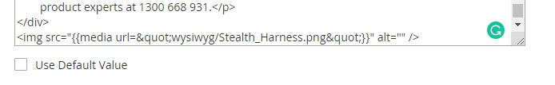

Copy the text from the equal sign and paste it into Visual studio code in the same spot in the <img> attribute.

Then just select all, copy, and then select all and paste in Magento backend.